**41st SALEM APRIL FOOL'S RACE**

Run in scenic and historic Salem, N.Y. Numerous prizes and fun for all--expert or

novice runners. The scenic runs begin at Salem High School and end there.

**Date:** Saturday, April 2, 2022

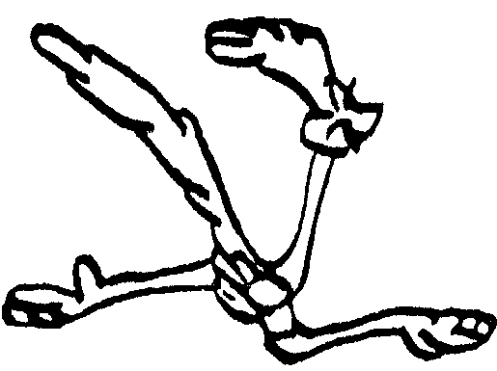

Salem April

Fool’s Race 2022

**Class of 2024**

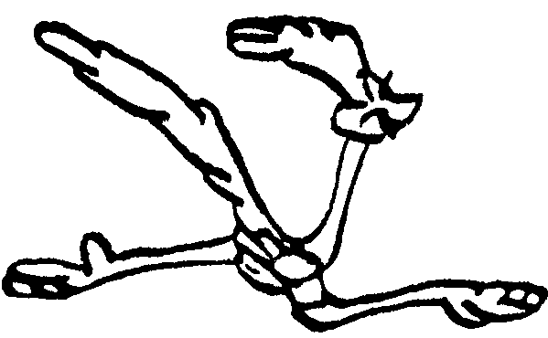

April Fool’s Race 2005



The Mink’s Eye

Literary Magazine



April Fool’s Race 2005



The Mink’s Eye

Literary Magazine



April Fool’s Race 2005



The Mink’s Eye

Literary Magazine



April Fool’s Race 2005



The Mink’s Eye

Literary Magazine

**Time:** 9 AM 10K race (NEW START TIME)



April Fool’s Race 2005

10:00 AM 1 mile children's race (ages 14 and under)

10:30 AM 5K race (NEW START TIME)

**Entry Fee:** $20.00 registration on race day

$ 15.00 if registered before March 30

$ 6.00 for 1 mile race (pre-race or race day)

(you can run in two races for one entry fee)

All entrants will receive an April Fool's T-shirt

(Child medium and large available)

Proceeds support the Rotary student exchange program and the Salem Central School Class of 2024

Food concession and water stops provided by Salem Boy Scout Troop 61

**Awards:** 1 mile - all entrants will receive a ribbon

5K and 10K - awards for first place in each race

awards for first in each age group (no duplicates)

**Age Groups:** 1 mile: 5-6, 7-8, 9-10, 11-12, 13-14

5K, 10K: 14 and under, 15-18, 19-24, 25-29, 30-34, 35-39, 40-44, 45-49, 50-54, 55-59, 60, 70+,80+

# ---------------------------------------------------

In consideration of your accepting this entry, I, the undersigned intending to be legally

bound, hearby for myself, my heirs, executors, and administrators, waive and release any and all rights

and claims for damages I may have against the following organizations: the Salem Racing committee,

the Salem Central School, the Town and Village of Salem, the Salem Rotary Club, and their representatives,

successors, and assigns, for any and all injuries suffered by me in said event of April 2, 2022. I verify that I

am physically fit and have sufficiently trained for the completion of the races I enter.

**Signature__________________________ Parent Signature_________________________**

(required if entrant is under 18 years old)

(Please print)

**Name___________________________________ Age______ Male______Female______**

**Address_________________________________ Phone_________________________**

**City____________________State_____ Zip_________ Email_______________________**

**Race: 1 mile _______ 5K _________ 10K ____________**

**T-shirt size: Adult's small_______ medium________ large________ x-large_______**

**Child medium**________ **Child large**____________

Make checks payable to: **The Salem Racing Committee**

Send to: Dan Sheldon, 4361 State Route 22, Salem, NY 12865 phone: 518-854-9262